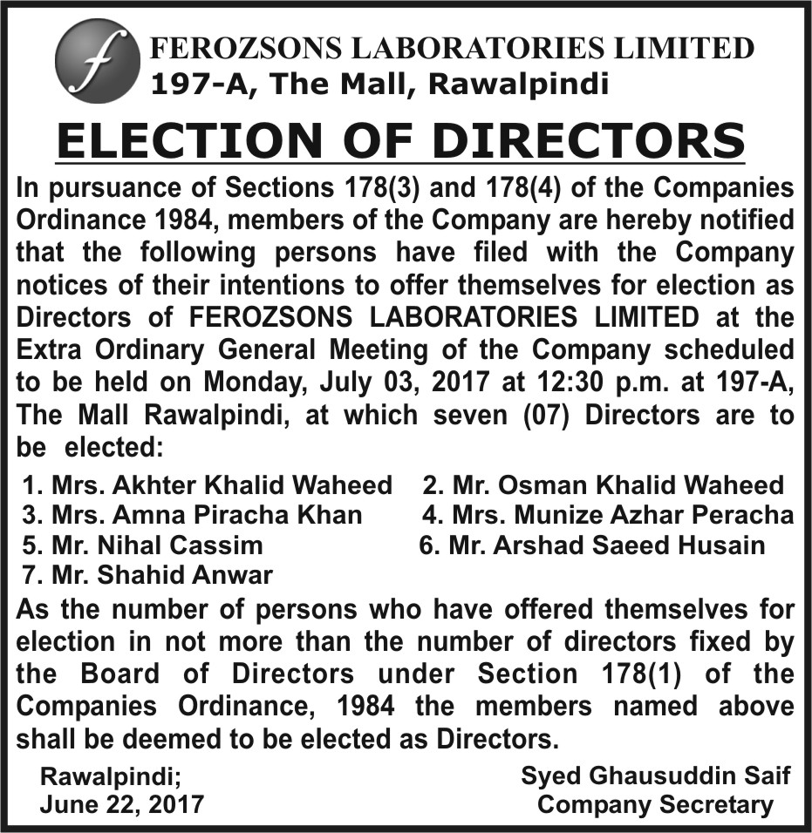

Mrs. Akhter Khalid Waheed
Mrs. Akhter Khalid Waheed assumed the role of Chairperson and Chief Executive of Ferozsons in 1992 following the untimely death of her husband Mr. Khalid Waheed, who had established the company from its infancy in 1956. During her tenure as CEO, Mrs. Waheed ably led the company and improved its sales and profitably consistently. In the period, the Company was awarded the Karachi Stock Exchange’s Top 25 Companies Award six times and developed alliances to expand the company’s role in healthcare. Mrs. Waheed holds a Bachelor’s Degree in Fine Art from the University of Punjab.
Mr. Osman Khalid Waheed
Osman Khalid Waheed is the CEO of Ferozsons Laboratories Limited. He joined the company in 1993 after obtaining his undergraduate degree from Harvard University, USA. He has worked in logistics, sales and marketing before assuming the role of company president in 1999. During this period, the company expanded its portfolio of medical solutions for critical diseases by forging alliances with a number of leading international partners including the Boston Scientific Inc., USA the world’s leading manufacturer of medical devices, a joint venture with the Bago Group of Argentina to establish BF Biosciences Limited, Pakistan’s first biotech pharmaceutical manufacturing company and Gilead Sciences, Inc. USA for their range of Hepatitis C and anti-viral therapies to name a few. Mr. Waheed is currently serving on the boards of a number of companies including IGI Insurance, Lahore University of Management Sciences (LUMS), Murree Brewery, Nestle Pakistan Limited, and has previously served on the boards of Trade Development Authority of Pakistan (TDAP), Pakistan Industrial Development Corporation (PIDC), and as President of the Rawalpindi Chamber of Commerce and Industries.
Mrs. Amna Piracha Khan
Mrs. Amna Piracha Khan is serving on the Board of Directors since 2014. She is currently Partner of Khan & Piracha – a legal firm providing services to various national and multinational companies and institutions, diplomatic missions on civil, corporate, power and energy, investment, operational issues, property and land matters as well as on labour laws and human resource matters. Mrs. Piracha holds a Masters in Journalism from Punjab University, a Masters in Comparative Literature from University of Nice in France in addition to holding a Masters in German language and a law degree from University of Sindh in Karachi. Mrs. Piracha has previously been a Member of the National Assembly of Pakistan (1989-90), member of the Pakistan's delegate to the Inter Parliamentarian Union meeting in Geneva (1989) and Pakistan's nominee for election to the United Nations Human Rights Commission (1996). She has also been a trustee for Mianwali Education Trust.
Mrs. Munize Azhar Peracha
Mrs. Munize Azhar Peracha has been serving on the Board of Directors of the Company since 1984. She is an architect by profession and has held senior management positions in various companies. She has been associated with Wasif Ali & Associates and Team A Ventures Private Limited where she has gained experience in Architecture as well as Marketing. Mrs. Peracha holds a Bachelors degree in Architecture from the National College of Arts.
Mr. Nihal Cassim
Nihal Cassim is associated with Ferozsons Laboratories Limited since 2005. He is the Chief Executive of Safeway Fund Limited, an investment vehicle based in Karachi. Mr. Cassim has had extensive corporate finance experience handling advisory services for various clients. In Canada, he was Vice-President and Head of small-cap Investment Banking for First Associates’ (now Blackmont Capital, a CI Financial Company). Prior to this, Mr. Cassim was responsible for the corporate development of TVX Gold Inc. and was involved in its $4 billion merger with Kinross Gold. He began his investment banking career at HSBC Securities, Canada.
Mr. Cassim is an MBA (Finance & MIS) from McGill University. In addition to his position at Ferozsons Laboratories Limited, he is currently a Director on the Boards and Audit Committees of Safeway Fund Limited, Pakistan Oilfields Limited and National Institutional Facilitation Technologies (Pvt) Limited (NIFT) and its subsidiary ISM (Pvt) Limted. Nihal has served two terms as a director on the Board of Mutual Funds Association of Pakistan.
Mr. Arshad Saeed Husain

Mr. Arshad Saeed Husain is the Chief Executive Officer of Aman Health Care Services. Aman Health has created healthcare systems ranging from Emergency Medical Services through the state of the art, life-saving Aman Ambulances, Community Health Program aimed at reducing sickness and mortality among the marginalized to offering free consultations, advice and triage for the most common illnesses over the phone through TeleHealth.

Mr. Arshad has over 25 years of broad based commercial experience working for leading multinational companies in Pharmaceuticals, FMCG and Life Sciences sectors. For the past ten years, ha has been CEO of publicly listed and private companies with a strong track record of achieving revenue, profit and business growth.

Prior to joining the Aman Foundation, Mr. Arshad served as the Managing Director of Abbott Laboratories Pakistan Limited. Earlier, he was associated with Syngenta Pakistan Limited as Managing Director and with PT Syngenta, Indonesia as president Director. He has also served in senior leadership positions at GlaxoSmithKline Pakistan Limited and ICI Pakistan Limited.

Mr. Arshad served as the President of the American Business Council, a chamber of U.S. Businesses and one of the largest group of single country overseas investors in Pakistan. He was also Chairman of the Pharma Bureau, representing research based multinational pharmaceutical companies in Pakistan. He was also the founding member of the Swiss Business Council and Chairman of CropLife Pakistan. He is also a member of the board of Directors of the Rotary Club of Karachi Metropolitan.
.
Mr. Arshad is a graduate from the London School of Economics and Political Sciences, with a specialization in International Trade and Development.

Mr. Shahid Anwar
Mr. Shahid Anwar is a nominee Independent Director on the Board of Ferozsons since 2010. Affiliated with the National Investment Trust (NIT), Mr. Anwar has extensive experience in the areas of Operations and Personnel. He is currently the Head of MD’s Secretariat and Personnel Department at NIT. Mr. Anwar started his career with the Investment Corporation of Pakistan where he served in various departments including research & economics and operations. He has served on the boards of a number of companies including Bata Pakistan, Lafarge Cement and Soneri Bank. He holds an MBA and a Diploma from the Institute of Bankers in Pakistan.

